Enzymes Regulate / Catalyze Biological Reactions

* Reactants closer together
* Different classes to increase reaction rates by 1000 - 1010 times
* Restrict possible conformation changes

1. Dissecting reaction into elementary reactions
2. Determine number of species in reaction systems
3. Assumptions --> steady state, [transition] = constant, highly unstable, amount very small
4. Solve for transition concentrations with algebra
5. Simplify/ make assumptions to see if it fits the observations

Common rate expression

A[S]/(B + [S]) = -r

When [S] is very small, reaction rate = A/B \* [S] (first order reaction)

When [S] is very large, reaction rate = A (zero order reaction)

Michaelis-Menten Kinetics (M&M)

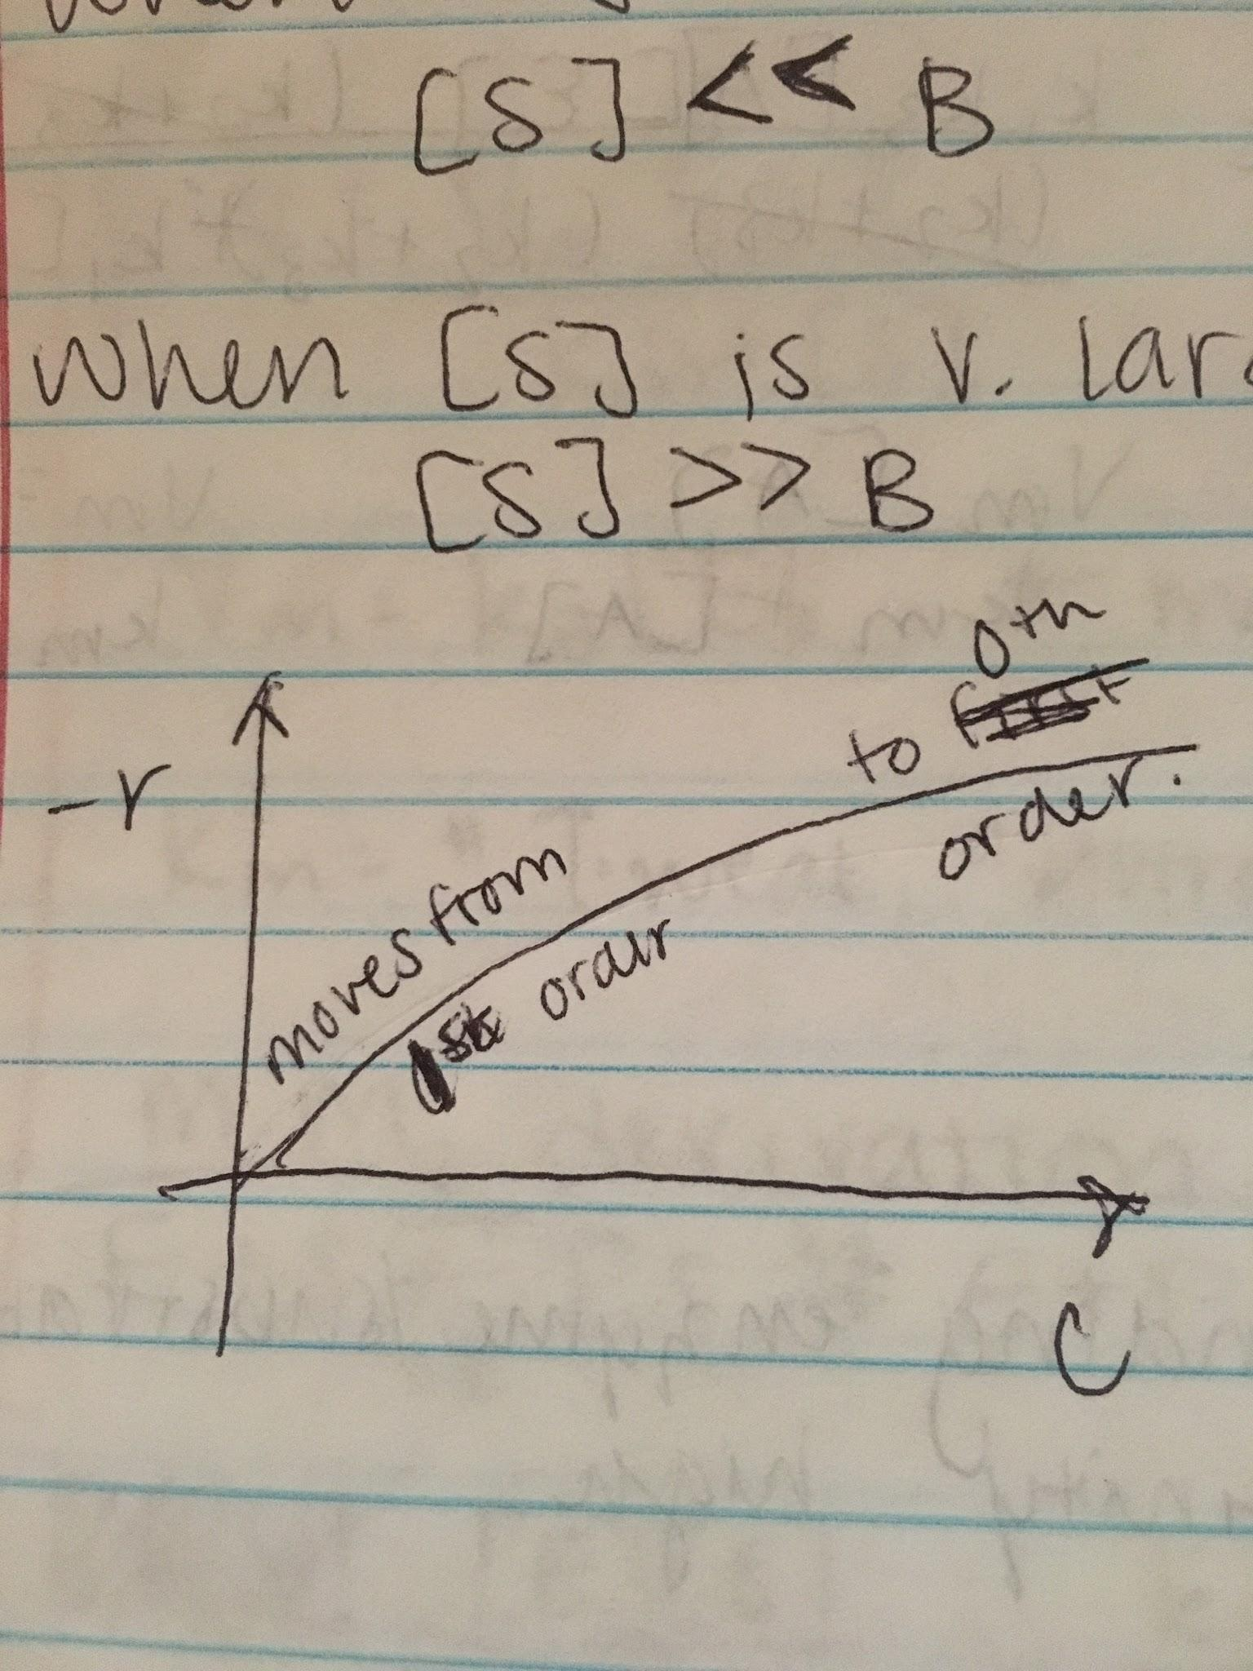

Example: A + E <--> AE --> B + E

A + E -->k1 AE

AE -->k2 A + E

AE -->k3 B + E

-rA = k1CACE - k2CAE

-rE = k1CACE - k2CAE - k3CAE

-rAE = -k1CACe + k2CAE + k3CAE = 0 (assumption d[AE]/dt = 0)

-rB = -k3CAE

Assume [E0] = [AE] + [E]

k2CAE + k3CAE = k1CACE

CAE(k2 + k3) = k1CACE

CAE = k1CACE/(k2 + k3)

Allosteric: binding of substrate on one site affects binding at another site

[E0] = k1[A][E]/(k2 + k3) + [E] --> solve for [E]

rB = k3k1[A][E]/(k2 + k3) = k1k3[A][E]/((k2 + k3) + k1[A])

rB = k3[E0][A]/(k2+k3/k1) + [A] = Vm[A]/Km + [A]

Vm = k3[E0]

Km = (k2 + k3)/k1

When Km is small: binding enzyme/substrates strong, affinity high

Induced fit: flexible structure to accomodate substrates